**Name: Qianzi Xu (Rachel)**

**CMSC110 Introduction to Computing  
Assignment#3 (Due on Tuesday, October 7, 2014)**

**Description and Thoughts**

Figure 1: Star Mandala with Colors

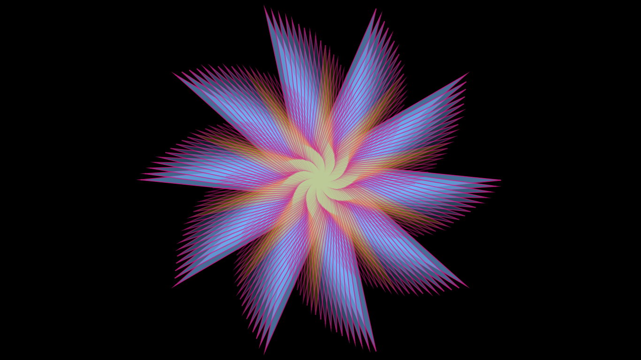

**[Insert your Image here]**

This is the star mandala I created using trig functions and loops. This pattern looks complicated but the code is surprisingly simple (compared to my expectation). It turned out that there were multiple ways to draw a star; after it’s done, the task became drawing more stars that differs from the first one to create a striking visual effect. I decreased the size of the star and rotated it each time I drew it; I also colored them differently using “if” conditions (it’s clear from the yellow part of the image that the whole image is really formed by a lot of regular-shaped star). I tried lots of different combinations of values specified in the program (the number of stars or the step of decrease in size etc.) and I was surprised by how changing affected the overall structure of the image.

I encountered problems during this process, too. At first, I put the part of the program that describes how to draw multiple versions of the star into draw () function. The result was strange. Then I found out that since the star mandala is drawn from the moment the program starts running and them remained stagnant, putting this part of the program in the setup() function would fix the problem. Another problem came when I almost finished the mandala. I wanted to make some improvement by making the edges of the star blurry. I tried noise () function for the strokeWeight attribute, but didn’t succeed. Probably it’s because noise () function is not easily applied to shapes like this.